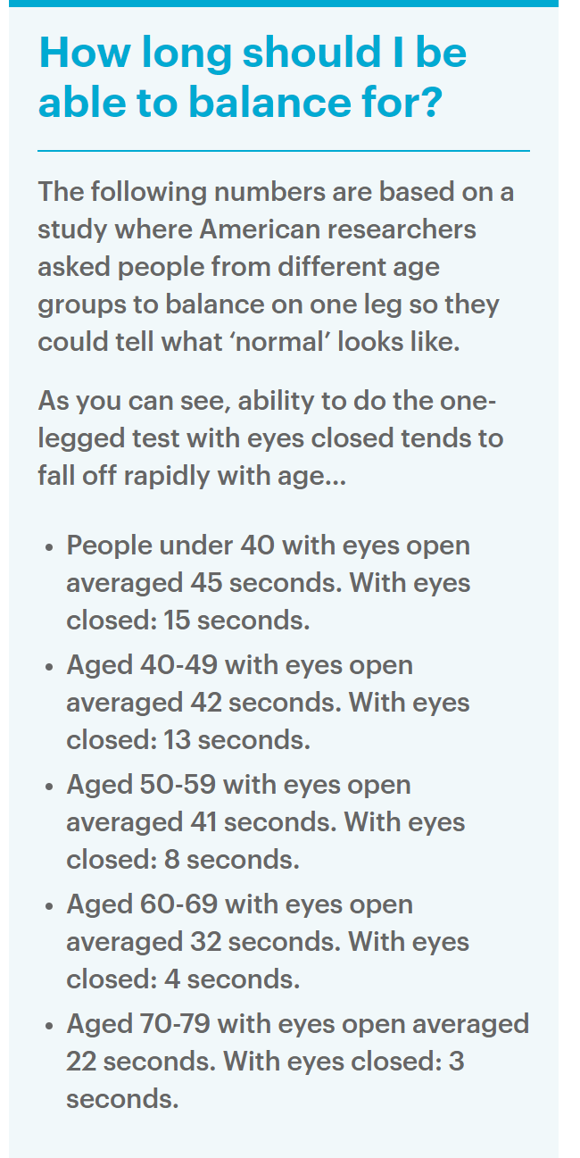

**For more details, please use the following link:**

* [How’s Your Balance? Take This 30-Second Test To Find Out - Save Our Bones](https://saveourbones.com/hows-your-balance-take-this-30-second-test-to-find-out/)
* [Standing on One Leg for 10 Seconds and Your Health (healthline.com)](https://www.healthline.com/health-news/can-you-stand-on-one-leg-for-10-seconds-what-that-tells-you-about-your-overall-health)
* [How Long Should I Be Able To Balance on One Leg? | Posture Movement Pain](https://posturemovementpain.com/2014/01/30/how-long-should-i-be-able-to-balance-on-one-leg/)

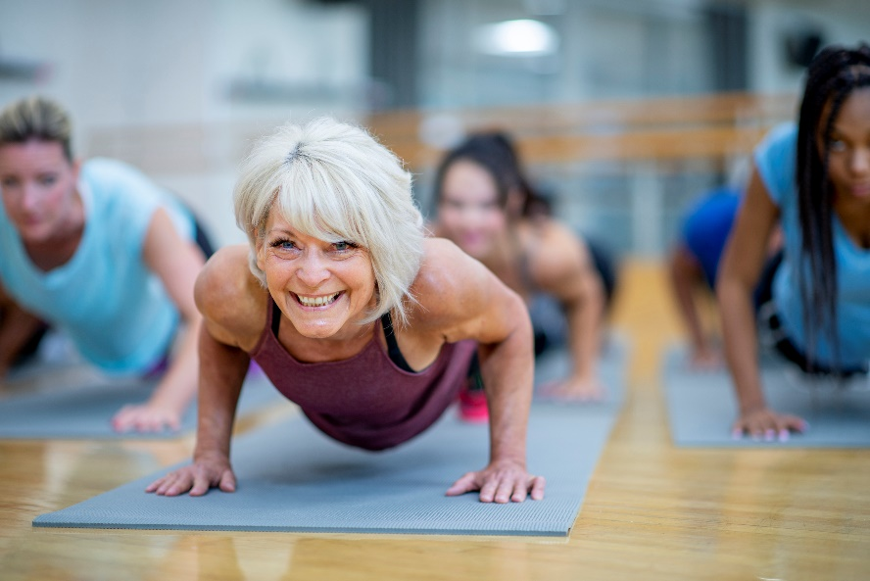

**Here are the best ways to**

**improve balance:**

**Stretching:**

Improving your flexibility can result in better balance. Stretches can also help improve your posture and lead to better stability and balance. Tight muscles can throw off your center of balance and make you more susceptible to trips and falls. Doing stretches that target key muscles will increase the range of motion (ROM) and improve your balance.

Top 4 Stretches to improve balance:

1. Standing Calf Stretch
2. Hip Stretch
3. Hamstring stretch
4. Standing Quad Stretch

**For more details on these stretches please use the following link:**

[4 Essential Stretches That Improve Your Balance | Prevention](https://www.prevention.com/fitness/a20482293/4-essential-stretches-that-improve-your-balance/)

**Mobility Training:**

Joint stiffness can lead to poor mobility, which you’ve probably noticed when you been getting out of bed or even getting up and down from a chair. Better mobility can lead to improve balance and coordination which allows us to stay more active.

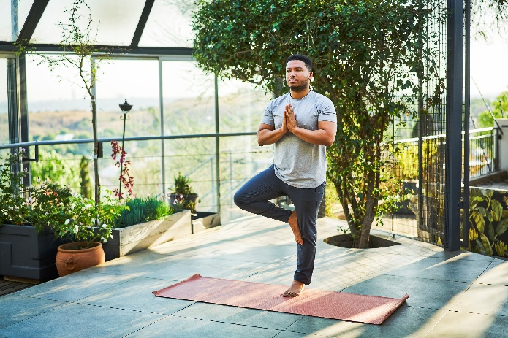Top 6 Mobility Exercises to improve Longevity:

1. Tightrope Walking
2. Tree Pose
3. Lying Down Marches
4. Lateral Toe Taps
5. Standing Marches
6. Single-Leg Stance

**For more details on these mobility exercises please use the following link:**

[The 6 Best Mobility Exercises for Longevity | Well+Good (wellandgood.com)](https://www.wellandgood.com/best-mobility-exercises-for-longevity/#:~:text=6%20best%20mobility%20exercises%20for%20longevity%20and%20healthy,Standing%20marches%20...%206%206.%20Single-leg%20stance%20)

[Want to Age Well? Improve Your Balance With This 5-Minute Foot-Mobility Sequence | livestrong](https://www.livestrong.com/article/13773987-5-minute-foot-mobility-sequence/)

**Exercising:**

Strengthening the muscles in your legs, core, and arms can lead to improvements in your balance. A general progression to get more challenging starts at a hard surface progress to carpet, or a thin yoga mat, a thick mat and finally an unstable surface such as a BOSU. A tennis shoe provides more stability thus making barefoot more challenging.

There are many different types of exercises you can do to help improve your balance. Ask a qualified fitness professional if you need help putting together a training program.

**Below are some clinically approved educational sources for balance exercises:**

* [5 Exercises to Train Balance in Motion (acefitness.org)](https://www.acefitness.org/resources/pros/expert-articles/6524/5-exercises-to-train-balance-in-motion/)
* [5 TRX Exercises to Improve Balance (acefitness.org)](https://www.acefitness.org/resources/pros/expert-articles/6501/5-trx-exercises-to-improve-balance/)
* [5 Ways to Progress Traditional Balance Exercises (acefitness.org)](https://www.acefitness.org/resources/pros/expert-articles/5658/5-ways-to-progress-traditional-balance-exercises/)
* [BOSU Balance Exercises | 7 Basic BOSU Exercises to Try (acefitness.org)](https://www.acefitness.org/resources/pros/expert-articles/5819/7-basic-bosu-balance-exercises/)
* [Balance Exercises: 5 Core Exercises to Improve Balance | ACE Blog (acefitness.org)](https://www.acefitness.org/resources/pros/expert-articles/6474/5-core-exercises-to-improve-balance/)

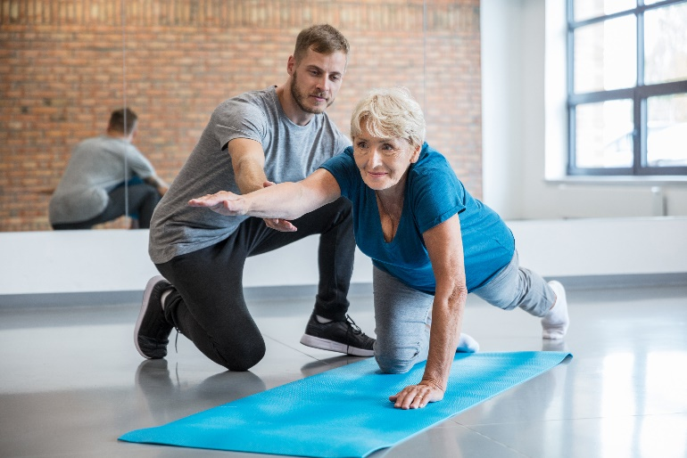**Top 8 conditions that can affect**

**your balance:**

1. Inner Ear Problems
2. Vision Problems
3. Muscle & Joint Problems
4. Nervous System Problems
5. Heart Problems
6. Anxiety & Stress
7. Diabetes
8. Medications

**For more details on these conditions please use the following link:**

[8 Health Conditions That Can Affect Your Balance (healthgrades.com)](https://www.healthgrades.com/right-care/symptoms-and-conditions/8-health-conditions-that-can-affect-your-balance#:~:text=8%20Health%20Conditions%20That%20Can%20Affect%20Your%20Balance,7%207.%20Diabetes%20...%208%208.%20Medications%20)

**Balance is a vital component of health and is essential for activities of daily living. Balance is especially important for older adults in the hope to reduce the risk of falls and injuries. Visual cues from our eyes give us information about where we are in a space. Therefore, it can be difficult to keep your balance with your eyes closed. Your eyes also send signals to your brain, telling your joints and muscles where and how to move. Remember when doing balancing exercises always use precaution and have a chair or wall near you in case you fall.**

