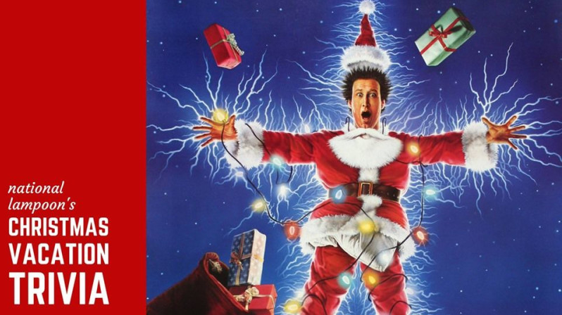

- In order to distract the family, what animal did Clark tell them he saw? _______________

- What is Eddie’s dog’s name?_______________

- What does Mr. Shirley call Clark? _______________

- In the beginning of the movie, what did Clark and his family get stuck under while driving? _______________

- What did Clark receive as his Christmas bonus? _______________

- How much money did Clark put down, as a down payment for the swimming pool? _______________

- What were the Griswold’s snooty neighbors’ first names? _______________

- What does Clark use to put up lights on his house? _______________

- What type of animal is in the Christmas tree? ________________

- What does Clark wear on his head when using his chainsaw for the first time? ________________

Name When Completed:
