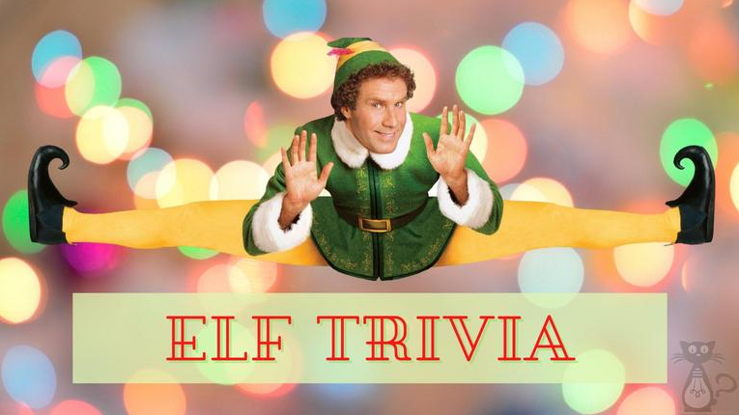

- How old was Will Ferrell when 'Elf' was filmed?_______________

- Where does Buddy originally come from? _______________
- What does Buddy mistake syrup for in the movie? _______________

- Who plays the role of Buddy in "Elf"?_______________

- What's the name of Buddy's love interest in the film? _______________

- What job does Buddy take on when he arrives in New York City? _______________

- What is the name of Buddy's biological father in the movie? _______________

- Which actor plays Buddy's father, Walter, in "Elf"?_______________

- What is the one rule that Buddy has to follow while working in the North Pole? _______________

- What gift does Buddy give to his half-brother Michael? _______________

Name When Completed:
