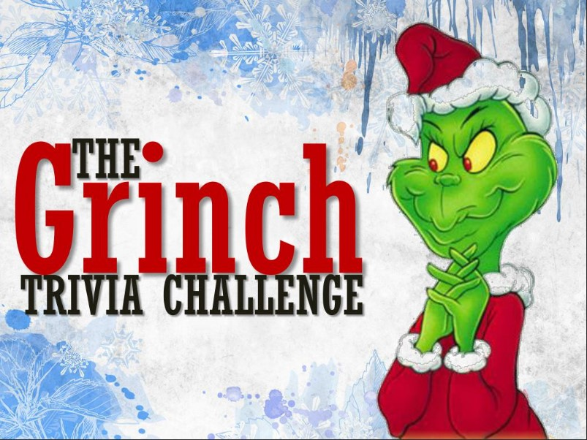

- What is the Grinch’s real name in the movie? _______________

- What is the Grinch’s residence? _______________

- What is the name of the little girl who befriends the Grinch in the film? _______________
- What instrument does the Grinch play in the Whobilation scene? _______________

- What is the Grinch's disguise when he goes down to Whoville on Christmas Eve? _______________

- What is the name of the Grinch's love interest in the film? _______________

- What is the Grinch's signature color? _______________

- What is the Grinch's sled powered by when he tries to steal Christmas? _______________

- Who played the Grinch in the 2000 film? _______________

- How many sizes does the Grinch's heart change during the film? _______________
Name When Completed:

