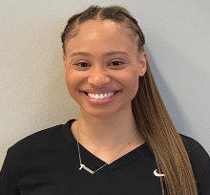
Staff Workout:
Taylor

Repeat Circuit 3x

- 6 Back and Forth Lateral Plank Walks:
(Start in a high plank with shoulders above wrists and abs tight. Walking sideways back and forth)

- 10 each side Single Leg Hip Bridges:
(Raise hips, tighten abs and glute muscles to support the lift, until shoulders and knees are in a straight line. Lower hips back to floor, repeat up and down)

- 8 Pike Push-Ups:
(Start in a hand plank position, lift hips up and back until your body forms an inverted V Shape. Keep arms and legs as straight as possible. Go down into a pushup and back up)

- 8 Half Squat Walks:
(Position feet shoulder-width apart, bend knees slightly into half-squat position, walk forward and backwards)

- 6 Side Plank Rotations:
(Start in a side plank position, lift body off the floor, bring arm above reaching for the sky and then reach underneath and behind your torso)

- 15 Bench Dips:
(Sit on the edge of a bench, gripping the bench with your hands facing out, and lift your butt off the bench. Lower your body by bending your elbows to a 90-degree angle)
Name When Completed:

