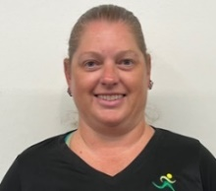
Staff Workout:
Tara

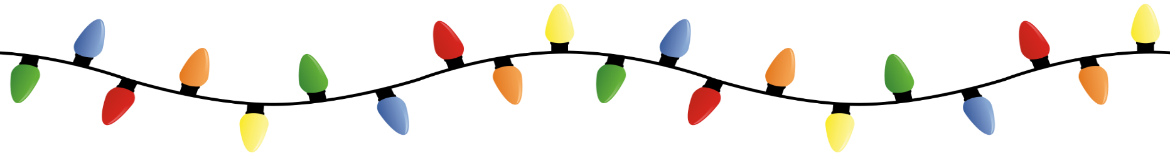

Low Impact Body Weight Routine
(Repeat 2-3X, can use weights)

Circuit 1:
- 60 sec Wall-sit
  - (Lean into a stable wall have feet hip width apart, legs perpendicular to hips, arms straight out)

- 10 V-up
  - (Lay on back with arms and legs extended out straight, bring arms and legs together, bend knees to modify)

- 10 Push-ups
  - (Lay on stomach, arms at chest level and press up using hands and toes, modify can be on knees or standing against a wall)

Circuit 2:
- 20 Stationary Lunges--each side
  - (Wide stance with one leg forward and other leg back, lunge down and press back up, make sure front knee does not go over toes)

- 20 sec Side Plank hold—each side
  - (Lay on side with bottom arm bent and legs out straight stacked, press up and hold, bend bottom leg to modify)

- 10 Triceps Bench dips
  - (Have hands beside hips on a bench or solid object that will not move, walk legs out straight and bent at elbows to dip upper body down, bend knees to modify)

Circuit 3:
- 30 Squats
  - (Stand with feet hip width apart, sit back in squat and make sure knees don’t go part toes, press through heels)

- 25 Mountain Climbers--with a twist
  - (On the floor in straight arm plank position, arms straight, hips down level with back, legs straight and dig toes into the ground, alternating driving knee into opposite elbow)

- 20 Shoulder Taps
  - (On the floor in straight arm plank position, arms straight, hips down and level with back, straight legs and dig toes into ground, tap opposite hand to opposite shoulder, can do this standing leaning into the wall to modify)

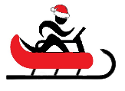
Name When Completed:

