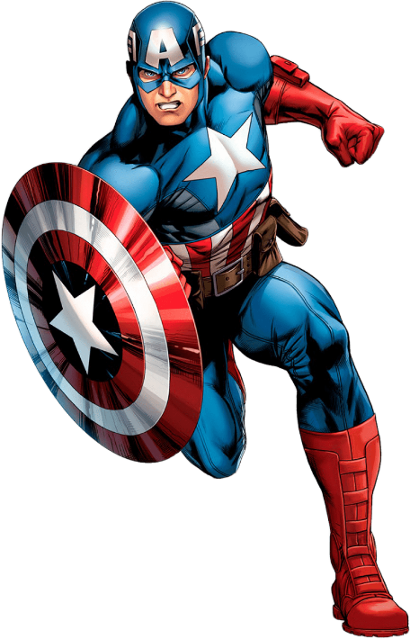
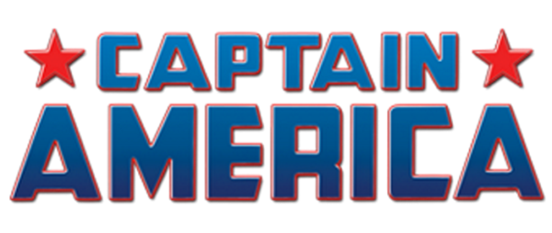

Welcome, aspiring superheroes, to the Super Soldier Workout! Channel the strength, agility, and endurance of the legendary Captain America as you embark on this epic fitness journey. Are you ready to unleash your full potential and become the ultimate symbol of justice? Let's begin!

1. Shield Plate Squats: 3 sets of 10 reps
- Hold a weighted plate or a dumbbell above head. Perform a squat, then explode upwards like you are wielding his shield.

2. Super Soldier Up & Down Plank: 3 sets of 5 reps each side
- Assume an elbow plank position. Go up to a hand plank with right then left, back down to elbows.

3. Military Alt. Hammer Curls: 3 sets of 20 reps
- Hold a dumbbell in each hand with palms facing upwards. Curl one weight at a time towards your shoulders.

4. Steve Rogers Alt. Reverse Lunges: 3 sets of 20 reps
- Hold a pair of dumbbells by your sides. Step backwards with one leg at a time.

5. Avenger Decline Sit-ups: 3 sets of 15 reps
- Lie on your back on decline bench and sit-up all the way up. Slowly lower back down.

6. Revitalize Jumping Jacks: 3 sets of 1 min
- Jump in place while spreading your arms and legs wide.

Exercises: | Sets  Reps  Wt. | M | T | W | T | F | S | S
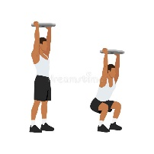  Plate  Squats | 3 sets
 | 10 reps
 | Wt.
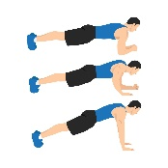  Up &  Down  Planks | 3 sets
 | 10 reps
 | Wt.
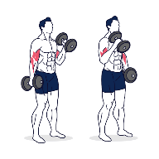  Alt.  Hammer  Curls | 3 sets
 | 20 reps
 | Wt.
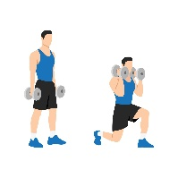  Alt.  Reverse  Lunge | 3 sets
 | 20 reps
 | Wt.
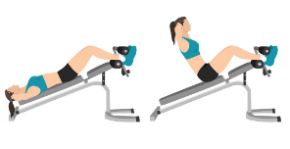  Decline  Sit-ups | 3 sets
 | 15 reps
 | Wt.
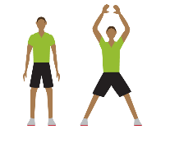  Jumping  Jacks | 3 sets
 | 1 min
 | Wt.

Congratulations, mighty warrior, on completing the Super Soldier Workout! By embracing the spirit of Captain America, you've pushed your limits and unlocked your true potential. Keep up the heroic effort and remember that with great strength comes great responsibility. Stay disciplined, stay determined, and continue to strive for greatness in all that you do. Until next time, go forth and inspire others with your newfound superhuman abilities!

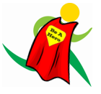
Name When Completed:

