Welcome to the Black Widow's Assassin Training Workout! Get ready to channel your inner spy and unleash your strength, agility, and precision like Natasha Romanoff herself. This workout is designed to sculpt your body into a lethal weapon while honing your skills like a true Avenger.

1. Widow's Strikes (Incline Push-ups): 3 sets of 10 reps
-Begin hands on bench or counter, hands slightly wider than shoulder-width apart. Lower your body until your chest nearly touches the bench or counter, then push back up explosively.

2. Sneaky Jumps (Jump Rope): 3 sets of 25 reps
-Jump up and down over the rope.

3. Red Room Lunges (Alt. Curtsy Lunges): 3 sets of 20 reps (10 each side)
-Keeping weight in right foot and hips square, take a big step back with left leg, crossing it behind right leg. Left knee should be in line with or to the right of right foot.

4. Widow's Web (Resistance Band Rows): 3 sets of 15 reps
-Attach a resistance band to a sturdy anchor point. Holding one end in each hand, pull the band towards your torso, squeezing your shoulder blades together.

5. Assassin's Agility (Box Jumps): 3 sets of 10 reps
-Find a sturdy box or platform and stand facing it. Jump onto the box, landing softly with both feet, then step back down.

6. Spy's Core Crunch (Russian Twists): 3 sets of 20 reps
-Sit on the ground with your knees bent and feet lifted off the floor. Hold a weight or medicine ball with both hands and twist your torso from side to side.
Exercises: | Sets  Reps  Wt. | M | T | W | T | F | S | S
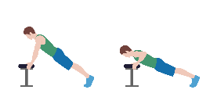  Incline  Pushups | 3 sets
 | 10 reps
 | Wt.
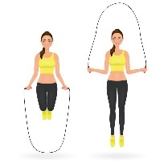  Jump  Rope | 3 sets
 | 25 reps
 | Wt.
Alt.  Curtsy  Lunge | 3 sets
 | 20 reps
 | Wt.
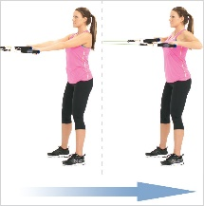  Resistance  Band  Rows | 3 sets
 | 15 reps
 | Wt.
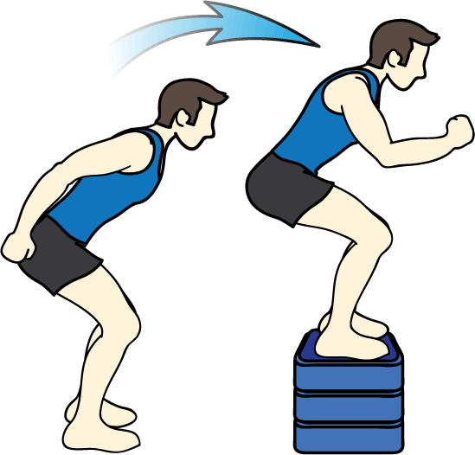  Box  Jumps | 3 sets
 | 10 reps
 | Wt.
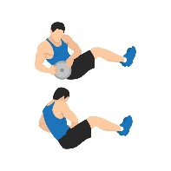  Russian  Twist | 3 sets
 | 20 reps
 | Wt.

Congratulations, agent! You've completed the Black Widow's Assassin Training Workout with flying colors. By mastering these exercises, you've proven yourself worthy of joining the ranks of Earth's mightiest heroes. Keep training, stay vigilant, and always be ready to unleash your inner superhero whenever duty calls. Until next time, stay strong and fearless like the Black Widow herself!

Name When Completed:

