Welcome to Cybernetic Shredder Workout designed to unleash your inner machine and push your limits. Get ready to channel the strength and resilience of Cyborg as we embark on a journey to transform our bodies into high-tech powerhouses. Gear up because this workout is about to take you to the next level!

1. Circuit Core Mt. Climbers: 3 sets of 30 secs.
-Hand plank and alt. each leg in while engaging your core and activating your cybernetic stability.

2. Pulse Cannon Alt. Front Raises: 3 sets of 20 reps
-Alternating lifting weights in the front emphasizing explosive power as you mimic Cyborg's energy blasts.

3. Bionic Bursts (Jump Squats): 3 sets of 15 reps
-Squat down and then add an explosive jump at the end to simulate Cyborg's powerful movements.

4. Cyber Alt. Lateral Raises: 3 sets of 20 reps
-Alternating lifting weights on the side enhancing your upper body strength and flexibility.

5. Tech Target Seated Knee Tucks: 3 sets of 15 reps
-Sit and put arms behind. Bringing your knees to your chest and kickout to engage your core.

6. Hydraulic Hyperextensions: 3 sets of 15 reps
- Lifting your upper body to strengthen your lower back and glutes. Add a weight for a challenge.
Exercises: | Sets  Reps  Wt. | M | T | W | T | F | S | S
Mt.  Climbers | 3 sets
 | 30 sec.
 | Wt.
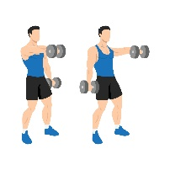  Alt.  Front  Raises | 3 sets
 | 20 reps
 | Wt.
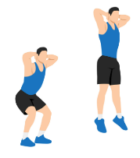  Jump  Squats | 3 sets
 | 15 reps
 | Wt.
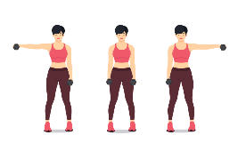  Alt.  Lateral  Raises | 3 sets
 | 20 reps
 | Wt.
Seated  Knee  Tucks | 3 sets
 | 15 reps
 | Wt.
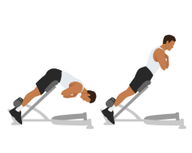  Back  Extension | 3 sets
 | 15 reps
 | Wt.

Congratulations, you've completed the Cybernetic Shredder Workout! You've embraced your inner cyborg, conquered the challenges, and pushed your limits. Remember, true strength comes from within, and you've just proven that you're a superhero in the making.

Name When Completed:

