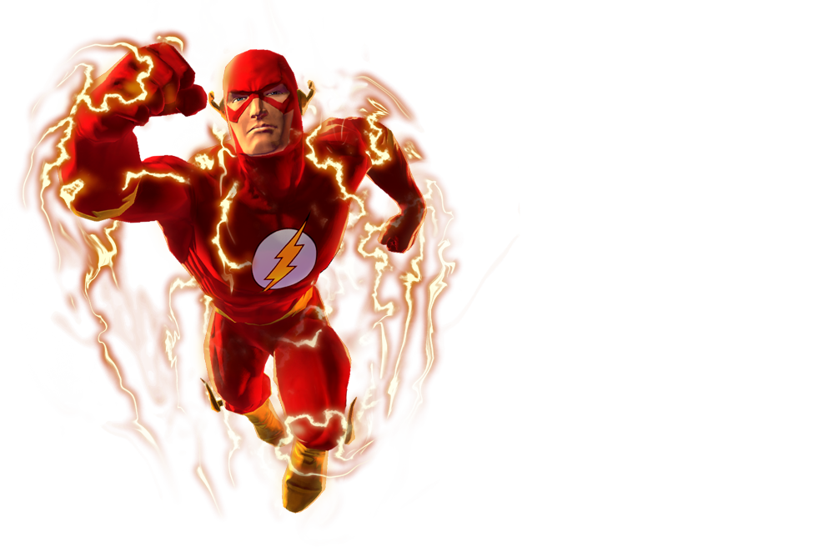

Embark on "The Speedster's Endurance Challenge," designed to enhance your stamina and speed, mirroring the awe-inspiring abilities of The Flash. This dynamic routine combines traditional cardio exercises with a superhero twist, ensuring an exhilarating experience that boosts your heart rate and improves your overall fitness.

1. High-Knee Sprints (3 sets, 30 seconds each)
- Run in place, bringing your knees up to waist level. Focus on speed and try to increase your pace with each set.

2. Lightning Lunge Jumps (3 sets, 12 reps each leg)
- Step forward into a lunge, dropping your back knee towards the ground. Explode back to standing, switching legs in mid-air.

3. Bolt Jump Rope (3 sets, 1 minute each)
- Go at the pace that is comfortable to you.

4. Speedster Sit-Ups (3 sets, 15 reps)
- Traditional sit-ups with a focus on speed and form.

5. Twisting Mountain Climbers (3 sets, 30 seconds each)
- Perform mountain climbers, bringing your knee to the opposite elbow for a core twist.

6. Flash Finisher: Sprint Intervals (5 sets, 20 seconds sprint/40 seconds walk)
- Sprint on treadmill or outside at maximum effort for 20 seconds. Walk or slowly jog for 40 seconds to recover. Repeat 5 sets in a row.

Exercises: | Sets  Reps  Wt. | M | T | W | T | F | S | S
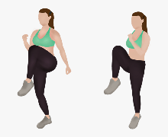  High  Knees | 3 sets
 | 30 sec.
 | Wt.
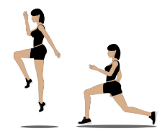  Lunge  Jump | 3 sets
 | 12 reps
 | Wt.
Jump  Rope | 3 sets
 | 1 min
 | Wt.
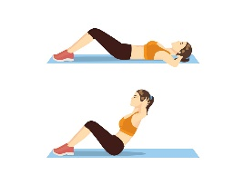  Sit-ups | 3 sets
 | 15 reps
 | Wt.
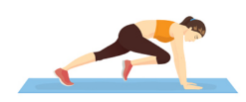  Mt.  Climbers | 3 sets
 | 30 sec.
 | Wt.
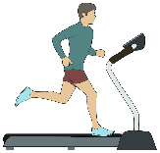  Sprint  Intervals | 3 sets
 | 20/40 sec.

Congratulations, you've just completed "The Speedster’s Endurance Challenge"! Like The Flash, you've demonstrated incredible speed and endurance. Remember, every superhero needs rest, so take time to recover and prepare for your next heroic adventure. Keep challenging yourself and never forget: your greatest superpower is your will to push forward!

Name When Completed:

