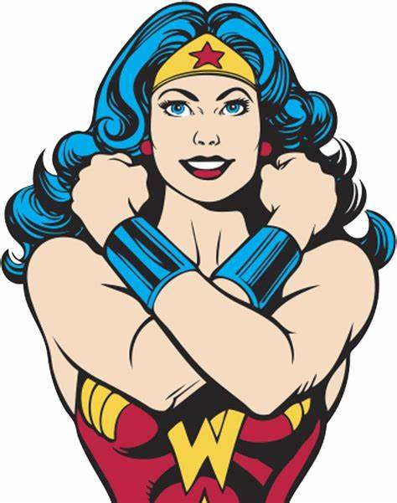

Welcome, warriors, to the "Warrior's Strength Workout" inspired by the resilience of Wonder Woman. Embrace the power within as we channel the strength and grace of an Amazonian warrior. Get ready to conquer this battle rope-infused workout.

1. Sword Strikes: 3 sets of 30 sec.
- Mimic sword strikes by performing quick, controlled waves with the battle rope. Feel the power surging through your arms and shoulders.

2. Lasso Lateral Arm Circles: 3 sets of 20 forward/backward
-Grab dumbbells, hold out lateral, and create circular motions forward and backwards, simulating Wonder Woman's iconic Lasso of Truth.

3. Shield Slams: 3 sets of 30 sec.
-Hold the battle rope with both hands and slam it to the ground, engaging your core and unleashing the power of the Amazonian shield.

4. Amazonian Reverse Lunge Jumps: 3 sets of 10 each side
-Go into reverse lunge and jump explosively, reaching for the sky as if leaping from island to island. Land softly and repeat, enhancing your lower body strength.

5. Bodyweight Squats: 3 sets of 10 reps
Channel the strength of an Amazonian by performing deep and controlled squats. Imagine lifting the weight of Themyscira with each repetition.

6. Golden Gauntlet Weighted Sit-ups: 3 sets of 10 reps
-Do a normal Sit-up and lift the weight above the head when you get up, channeling the strength of Wonder Woman's golden gauntlets.

Exercises: | Sets  Reps  Wt. | M | T | W | T | F | S | S
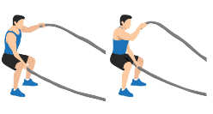  Rope  Alt. Arm  Waves | 3 sets
 | 30 sec.
 | Wt.
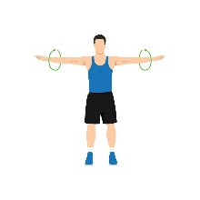  Lateral  Arm Circles  F/B | 3 sets
 | 20 reps
 | Wt.
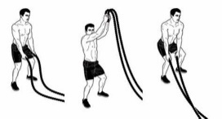  Rope  Slams | 3 sets
 | 30 sec.
 | Wt.
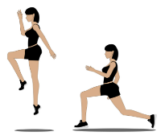  Reverse  Lunge  Jumps | 3 sets
 | 10 reps
 | Wt.
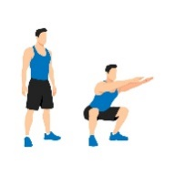  Bodyweight  Squats | 3 sets
 | 10 reps
 | Wt.
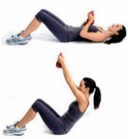  Weighted  Sit-ups | 3 sets
 | 15 reps
 | Wt.
Congratulations, warrior, on conquering the “Warrior’s Strength Workout." You've harnessed the strength, agility, and resilience of Wonder Woman. Carry this newfound power with you, knowing that you possess the heart of an Amazonian. Well done!

Name When Completed:

