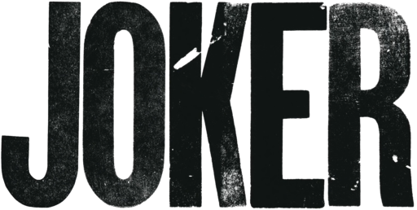

Welcome to the Joker's Chaos Workout, where we'll embrace the unpredictable and chaotic nature of the Clown Prince of Crime himself. This workout isn't for the faint of heart, but if you're ready to challenge your fitness with a twist of madness, let's get started!

Perform each exercise for 45 seconds, followed by a 15-second rest. Repeat the circuit 3x.

1. Ha-Ha Hurdles (Jumping Jacks)
- Jump in place while spreading your arms and legs wide.
- Add your own Joker-style laugh for fun!

2. Madcap Medicine Ball Mayhem (Squat and Press)
- Hold a weight or household item at chest level.
- Squat down, then explode up, pressing the weight overhead.

3. Grin and Bear It (Plank)
- Get into a plank position with your elbows on the ground.
- Smile like the Joker as you hold the plank for 45 seconds.

4. Chaos Climbers (Mountain Climbers)
- Start in a push-up position and alternate bringing your knees to your chest.

5. Joker's Jabs (Shadow Boxing)
- Pretend to box like the Joker, throwing fast and unpredictable punches.

6. Laughing Lunges (Reverse Lunges)
- Step back into a lunge, and as you come up, give a Joker-style laugh.

7. Crazy Card Crunches (Bicycle Crunches)
- Lie on your back, and bring your elbow to your opposite knee, mimicking shuffling a deck of cards.

Exercises: | Sets  Reps  Wt. | M | T | W | T | F | S | S
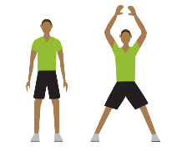  Jumping  Jacks | 3 Sets
 | 45 sec.
 | Wt.
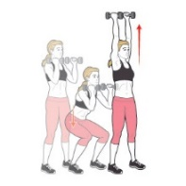  Squat &  Press | 3 Sets
 | 45 sec.
 | Wt.
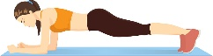  Plank | 3 Sets
 | 45 sec.
 | Wt.
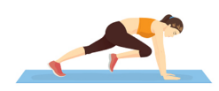  Mountain  Climbers | 3 Sets
 | 45 sec.
 | Wt.
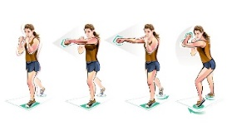  Shadow  Boxing | 3 Sets
 | 45 sec.
 | Wt.
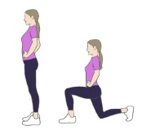  Reverse  Lunge | 3 Sets
 | 45 sec.
 | Wt.
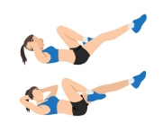  Bicycle  Crunch | 3 Sets
 | 45 sec.
 | Wt.

You've conquered Joker's chaos workout, embracing the unpredictability and intensity. Keep pushing boundaries and thriving in the chaos of your fitness journey.

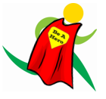
Name When Completed:

