Welcome to Harley's Chaos Core Crusher, where we defy convention and sculpt a core as unpredictable as Gotham's night sky. Get ready to unleash your inner mischief as we embark on a journey designed to ignite your rebellious spirit. So, tighten those pigtails and prepare to dive headfirst into the chaos!

1. Hyena Jump Squats: 3 sets of 10 reps
-Begin in a squat position, then explode upward into a jump while emitting your best hyena cackle.

2. Madcap Mountain Climbers: 3 sets of 20 reps
-Get ready to climb the peaks of insanity. Assume a plank position and alternate bringing your knees towards your chest in a rapid, climbing motion.

3. Psycho Sit-Ups: 3 sets of 10 reps
-Lie on your back with your arms behind head and your legs bent. Engage your core as you sit up explosively.

4. Joker Jackknives: 3 sets of 10 reps
-Lie on your back with your arms extended overhead and your legs straight. In one fluid motion, lift your upper body and legs off the ground, reaching your hands towards your feet.

5. Crazy Cardiac Crunch Clap: 3 sets of 20 reps
- Crunch up while bringing one knee towards your chest and clap under. Return to the starting position and repeat on the other side.

6. Harley's Havoc Reverse Lunge w/ High Kicks: 3 sets of 10 each side
-Stand tall and do a reverse lunge. On the way up, kick one leg up as high as you can.

Exercises: | Sets  Reps  Wt. | M | T | W | T | F | S | S
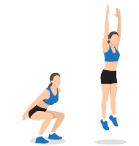  Jump  Squats | 3 sets
 | 10 reps
 | Wt.
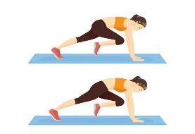  Mt.  Climbers | 3 sets
 | 20 reps
 | Wt.
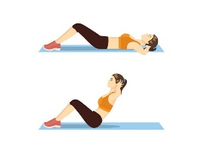  Sit-ups | 3 sets
 | 10 reps
 | Wt.
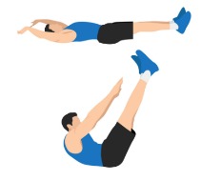  Jack  Knives | 3 sets
 | 10 reps
 | Wt.
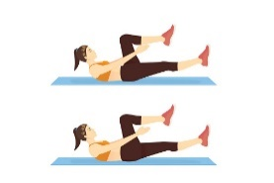  Crunch  Clap | 3 sets
 | 20 reps
 | Wt.
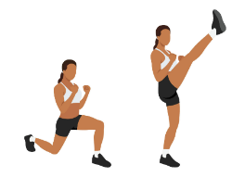  Reverse  Lunge  Hick Kick | 3 sets
 | 10 reps
 | Wt.

Congratulations on completing Harley's Chaos Core Crusher! You've embraced the madness, conquered each exercise with gusto, and unleashed your inner mischief-maker in style. Now go forth with confidence, knowing that your core is as strong and unpredictable as Harley herself. Until next time, keep causing chaos and spreading smiles wherever you go!

Name When Completed:

